Class 5–6: Operating System, Software & Computer Security

Introduction to Computer System
A computer system works with the help of two main components: Hardware and Software.
  - Hardware is the physical part (keyboard, CPU, monitor).
  - Software is the set of instructions that tells the hardware what to do.
A computer cannot function properly without software, and the most important software is the

Operating System (OS).

What is an Operating System (OS)?

Definition:
An Operating System (OS) is a system software that acts as a bridge between the user and the computer hardware.

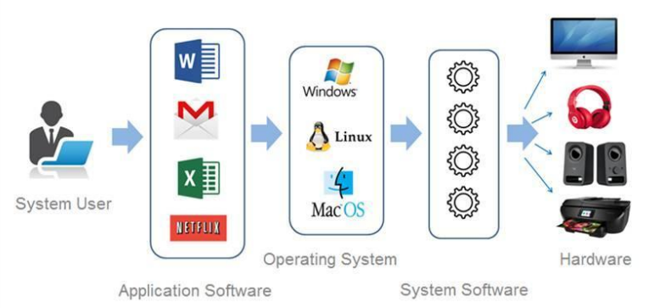

Why OS is Important:

- It makes the computer usable
- It controls all hardware components
- It allows users to run applications
- Without OS, computer is useless

Basic Working of OS:

- User gives input
- OS processes the requestOS instructs hardware
- Output is shown to user

Real-Life Example:
Think of the OS as a manager:
- User = Boss
- OS = Manager
- Hardware = Workers
The manager takes instructions from the boss and tells workers what to do.

Functions of Operating System

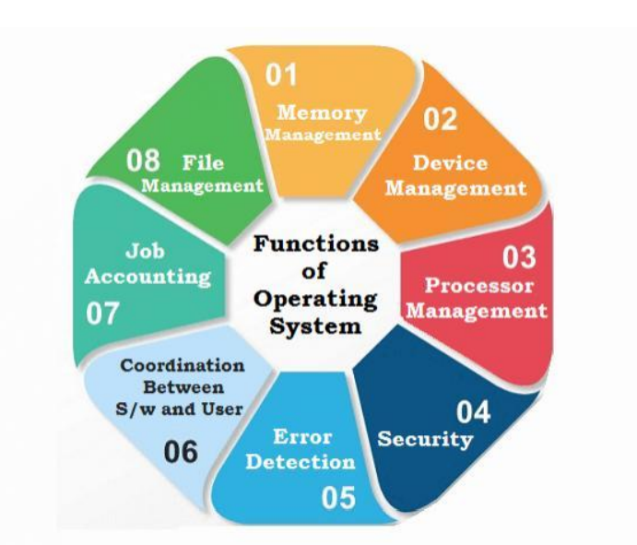

Process Management

  - Runs and manages programs
  - Allows multitasking (multiple apps at same time)
  - Decides which program runs first
Example: Listening to music while using browser

Memory Management

  - Manages RAM (temporary memory)
  - Allocates memory to different programs
  - Prevents memory conflicts

File Management

  - Organizes files and folders
  - Helps in storing and retrieving data
Example: Saving files in folders like Documents

Device Management

  - Controls input and output devices
  - Uses drivers to communicate with hardware
Examples: Keyboard, mouse, printer

Security Management

  - Protects system using passwords and permissions
  - Controls access to files and programs

Types of Operating Systems

Single User OS

  - Used by one user at a time
  - Common in personal computers

Multi User OS

  - Multiple users can use system simultaneously
  - Used in servers and organizations

Multitasking OS

  - Runs multiple applications at once
  - Improves efficiency

Real-Time OS (RTOS)

  - Provides instant response
  - Used in critical systems
Examples: Robotics, medical systems

Common Operating Systems

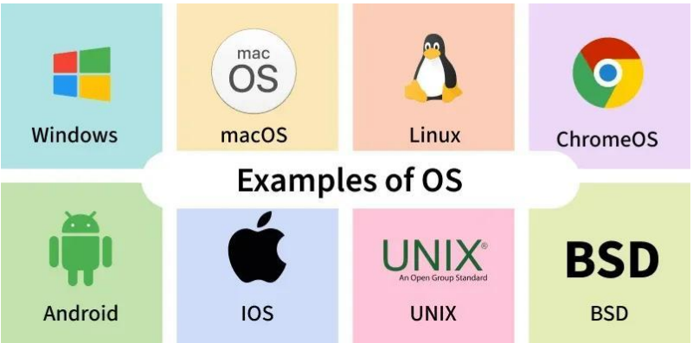

  - Windows: Used in PCs and laptops
  - Android: Used in mobile phones
  - macOS: Used in Apple devices
  - Linux: Open-source, used in servers and advanced systems

User Interface (UI)
User Interface is the way users interact with the computer.

GUI (Graphical User Interface)

  - Uses icons, buttons, windows
  - Easy to use

CLI (Command Line Interface)

  - Uses text commands
  - More powerful but difficult

Booting Process

What is Booting?
Booting is the process of starting the computer and loading the OS into memory (RAM).

Steps of Booting:
- Power button is pressed
- BIOS starts and checks hardware
- OS loads into RAM
- System becomes ready to use

What is BIOS?

  - Basic Input Output System
  - It checks hardware before OS starts

Proper Shutdown

What is Shutdown?
Shutdown is the process of safely turning off the computer.

Why Proper Shutdown is Important:

- Saves data
- Closes programs properly
- Prevents system damage

Risks of Improper Shutdown:

Data loss
- File corruption
- Operating System damage

Understanding Software

Definition:
Software is a set of instructions that tells the computer what to do.

Concept:

- Hardware = Body
- Software = Brain

Role of Software:

- Makes hardware useful
- Helps perform tasks
- Controls operations

Types of Software

System Software

  - Controls and manages computer
  - Runs in background
Examples: Operating System, Device Drivers

Application Software

  - Used by users for specific tasks

Examples:
  - Web browser (Chrome)
  - Word processor (MS Word)
  - Media player (VLC)

Difference Between System & Application Software

Feature | System Software | Application Software
Purpose | Runs computer | Performs user tasks
Usage | Background | On demand
Example | OS | Chrome, Word

Computer Virus & Security

What is a Virus?
A computer virus is a harmful program that damages the system or steals data.

Effects of Virus:

- Deletes files
- Slows system
- Shows unwanted ads
- Steals information

How Viruses Spread:

- Downloading from unknown websites
- Using infected pen drives
- Clicking unknown links
- Installing pirated software

Protecting Your Computer

Antivirus Software
Software that detects and removes viruses
Examples: Windows Defender, Quick Heal

Safety Practices:

- Scan pen drives before use
- Keep system updated
- Avoid unknown downloads
- Do not click suspicious links

Golden Rule:

“Free software can be costly”
(It may contain hidden viruses)

AI and Computer System

Connection with AI:
  - AI tools are also software
  - They run on OS
  - Require good system performance

Important Points:

  - High RAM improves AI performance
  - SSD increases speed
  - Secure system ensures safe AI usage

Assignment 1: Operating System Explorer

Teach & Check Activity

Person You Explained To:

- Which interface did they prefer? (GUI / CUI)

Why did they find it easy or difficult?

Reflection

What confusion did they have?

How did you explain it?

What did you learn while teaching?

Assignment 2: Inside Your Computer – BIOS & Startup Mystery

Understanding Concepts

What is BIOS (in your own words)?

What happens when you press the power button? (Step-by-step)
1. 2. 3. 4.

What is Booting Process?

Real-Life Scenario Task

If computer is switched off directly from power button daily:
Problems that can happen:
-

-

Why does this happen?

Teach & Check Activity

Explain: “Why proper shutdown is important”

Did they already know this?

What new thing did they learn from you?

Assignment 3: Operating System Comparison Challenge

Comparison Table

Feature | Windows | Android | iOS
Device Type
Price
Speed
Ease of Use
Customization
Security

Additional Details

Windows

- Latest Version:
- Advantages: 1. 2.
- Disadvantages: 1. 2.
- Preferred Users:

Android

- Latest Version:
- Advantages: 1. 2.
- Disadvantages: 1. 2.
- Preferred Users:

iOS

- Latest Version:
- Advantages: 1. 2.
- Disadvantages: 1. 2.
- Preferred Users:

Analysis Questions

Which OS is best for students and why?

Which OS is most secure and why?

Which OS gives more control/customization?

If budget is low, which OS is better and why?

Teach & Check Activity

Explain any one OS to someone

What questions did they ask?

What confusion did they have?

How did you explain it?

Smart Decision Task

Which OS will you choose and why?

What features are most important for you?

Which OS will you avoid and why?

Final Section: My Learning Advantage

3 Things I Can Explain Confidently:

1 Thing I Want to Improve:

